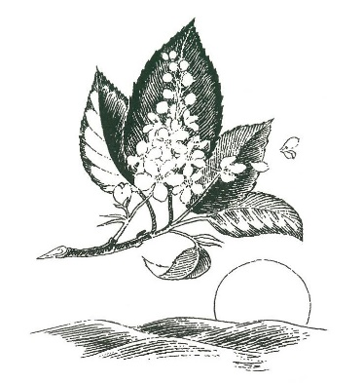

**Common Core State Standards for ELA**

* College and Career Readiness for Reading and Writing



* Reading for Literature
* Reading Informational Text
* Writing (Argumentative, Informative, Narrative, and Literary Response)
* Speaking and Listening
* Language Use

**Overview:** Students will consider their own views on courage, strength, values, and choices about growing up. It is the goal that through reading, writing, and listening comprehension activities students will analyze a variety of essential questions. It is also the goal for students to realize that what we do in school reflects our values and an important part of culture.

**Freytag’s Pyramid:** Exposition, Rising Action, Climax, Falling Action, Resolution

**The Writing Process:** Meaning, Development, Organization, Language Use, Conventions

**Writing Structure and Form**: Compare/Contrast, Thematic, Informal/Formal, Argumentative, Descriptive, Creative, and Journal Response, Paragraph and Essay Level

**Literary Elements/Techniques:** Theme, Conflict,Characterization, Setting, Point of View, Symbolism, Imagery, Irony, Protagonist, Antagonist, Rhyme Scheme, Meter, Metaphor, Simile, Figures of Speech, Satire, Tone, Mood, and Poetic Devices/Structure

**Possible Novels/Plays**

*Romeo and Juliet*, William Shakespeare

*The Old Man and the Sea*, Ernest Hemingway

*Two Old Women*, Velma Wallis

*Fever 1793,* Lauire Halse Anderson

*The House on Mango Street,* Sandra Cisneros

*The Education of Little Tree*, Forest Carter

*The Odyssey*, Homer

**Short Stories/Other**

*The Most Dangerous Game*, Richard Connell

*The Lady or the Tiger*, Frank Stockton

*The Necklace*, Guy de Maupassant

*A Very Old Man with Enormous Wings*, Gabriel Garcia Marquez

Mythology, Creation Stories

**Possible Projects**: Creatures of the Sea, Revolutionary Era, Portfolios, Oral Presentations, PowerPoint, Assignment Menus, Library Research, MLA, Choice Books

**Poets Explored:** Ralph Waldo Emerson, Robert Frost, Samuel Taylor Coleridge, Edgar Allan Poe, Langston Hughes, Emily Dickinson, Henry Wadsworth Longfellow, William Blake